[Practice: Congruence and Transformations](https://www.khanacademy.org/math/geometry-home/congruence/transformations-congruence/e/exploring-rigid-transformations-and-congruence)

[Practice: Determine Congruent Triangles](https://www.khanacademy.org/math/geometry-home/congruence/triangle-congruence/e/congruent_triangles_1)

[Practice: Find Angles in Triangles](https://www.khanacademy.org/math/geometry-home/congruence/working-with-triangles/e/triangle_angles_1)

[Practice: Find Angles in Congruent Triangles](https://www.khanacademy.org/math/geometry-home/congruence/working-with-triangles/e/congruent_triangles_2)

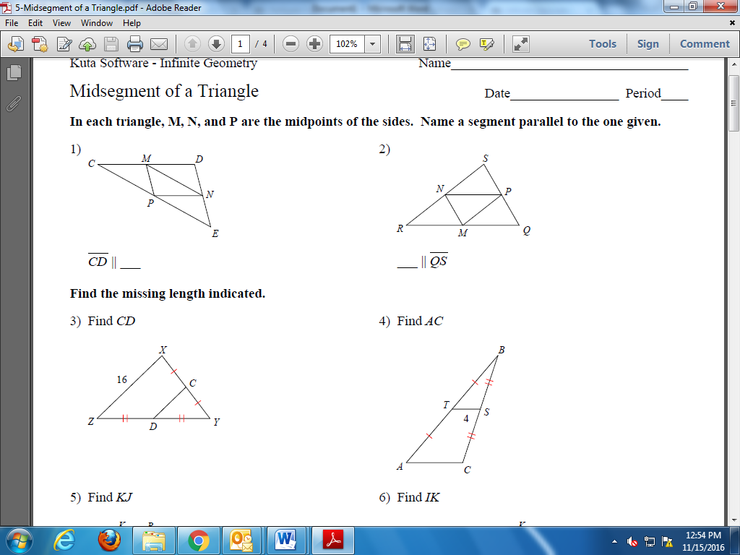**Triangle Midsegment Practice** – Do the following problems on your own paper

